Blossom all year with shrubs – only use open-flowered varieties

Month | Important shrubs | Super shrubs
January | Salix caprea pendula  Clematis cirrhosa (Winter)  Gorse (Ulex europeaus)  Hazel (Corylus avellana) | 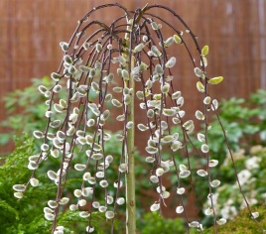
February | Erica Darleyensis (Winter heather) | 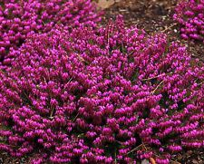
March | Daphne odora aureomarginata | 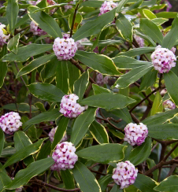
April | Ribes sanguineum | 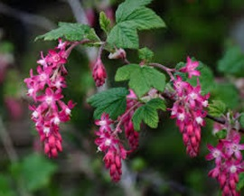
May | Chaenomeles japonica,  Weigelia  Rosmarinus officinalis  Philadelphus delavayi | 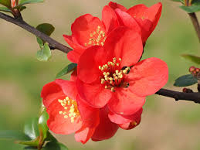
June | Cotoneaster simonsii  Erica darleyensis (Summer heather)  Ceanothus burkwoodii  Pyracantha watereri | 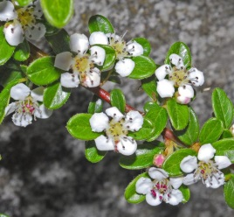
July | Rosa caninis  Lonicera Americana (Summer honeysuckle)  Syringa vulgaris | 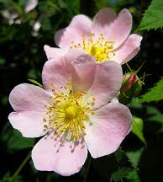
August | Lavendula hidcote  Potentilla fruticosa | 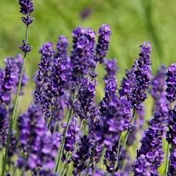
September | Buddelia davidii | 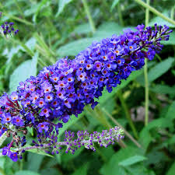
October | Salvia fulgens  Hebe “E A Bowles” | 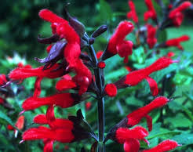
November | Abelia grandiflora | 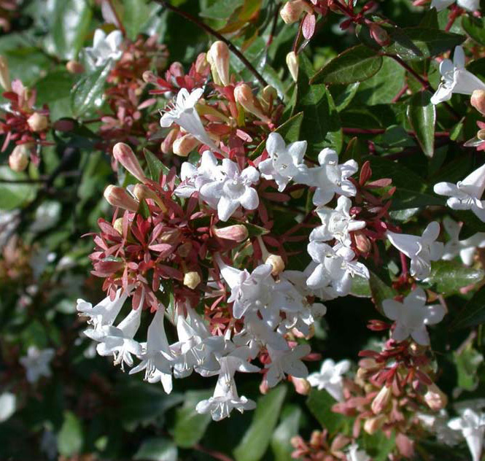
December | Mahonia japonica  Lonicera fragrantissima (Winter honeysuckle)  Viburnum bodnantense | 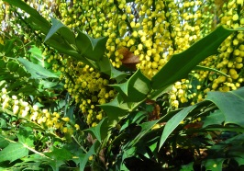

Other shrubs can be added, particularly open-flowered garden roses.

Adrian Doble (January 2020)

